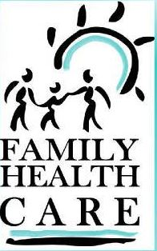
Form to Refuse Permission for a FREE
Dental Screening

Family Health Care
300-340 Southwest Boulevard
Kansas City, KS 66103
913-722-3100, ext 210
www.FHC-Smiles.org

If you would like your child to receive a FREE Dental Screening, DO NOT SIGN this form.

Dear Parent/Guardian:

Please provide the following information:

Student’s Name: ________________________________________________________________________

Teacher’s Name: ________________________________________________________________________

Grade: _________________________

On_____________ a dental screening/check will be provided to students AT NO COST to the family or school.

This will be a simple visual screening/check to look for cavities. It does not take the place of a regular exam in a dental office. All students will be screened unless form is brought back to school Nurse to OPT OUT.

NO, I DO NOT want my child to receive a free dental screening/check. (OPTING OUT from dental screening)

Parent/Guardian Signature: _______________________________________________________________ Date: _________________________________

Please return this form to the school nurse by this date: ________________________________________.

